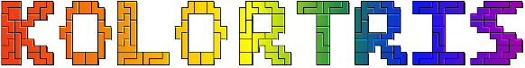

by Aldrich Asuncion

Instruction Manual

Table of Contents

The Main Menu 3

Multiplayer setup Screen 4

Host Game 5

Join Game 6

Game Screen 7

Rules 7

Default Controls 7

Game Screen Layout 7

Garbage Lines 8

Results Screen 9

# About the Game

Kolortris is a puzzle game based of off Tetris, with one major new mechanic: color matching! Blocks are now multicolored, and blocks can be cleared by placing colored blocks together.

# The Main Menu

Upon first starting the game, you will see this screen:

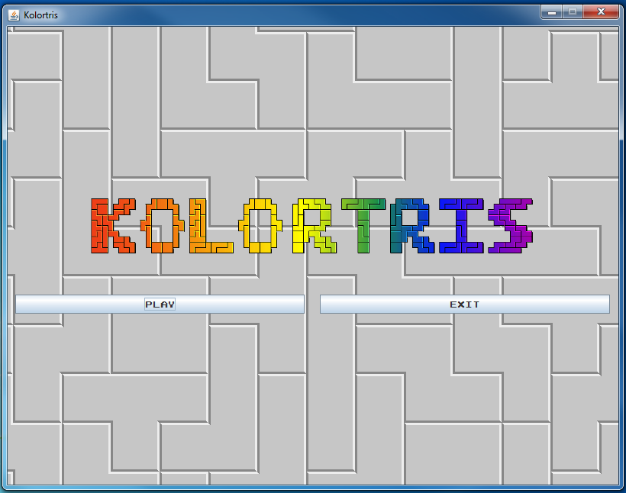

The Play button takes you to the Multiplayer screen (page 4)

The Exit button closes the game.

# Multiplayer setup Screen

The multiplayer setup screen allows you to set your name, and host / join games.

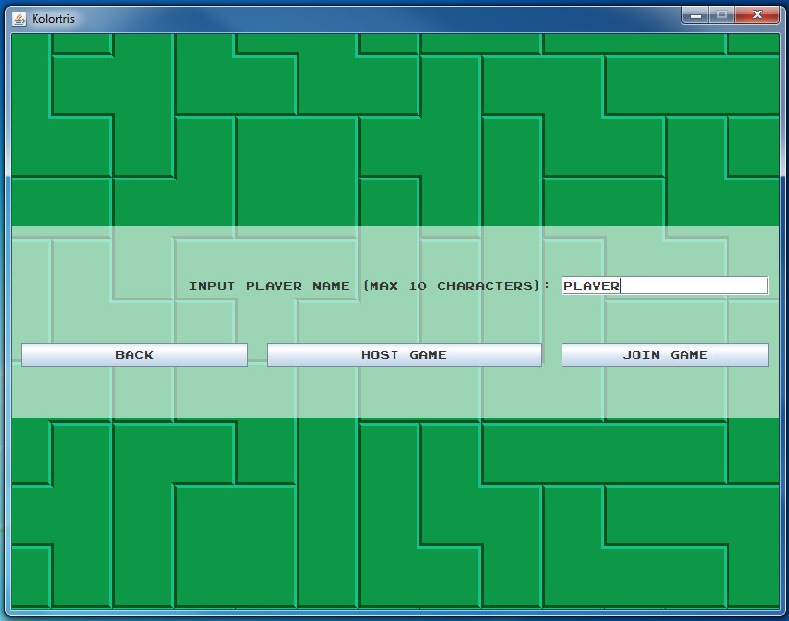

You can input your player name here (up to 10 characters)

Clicking the Host Game button will take you to the Host Game screen (page 5), where you can wait for other players to connect.

Clicking the Join Game button will allow you to connect to a player using the Join Game screen (page 6)

Clicking the Back button will take you back to the Main Menu (page 3)

# Host Game

While at the Host Game screen, the game will wait for other players to connect.

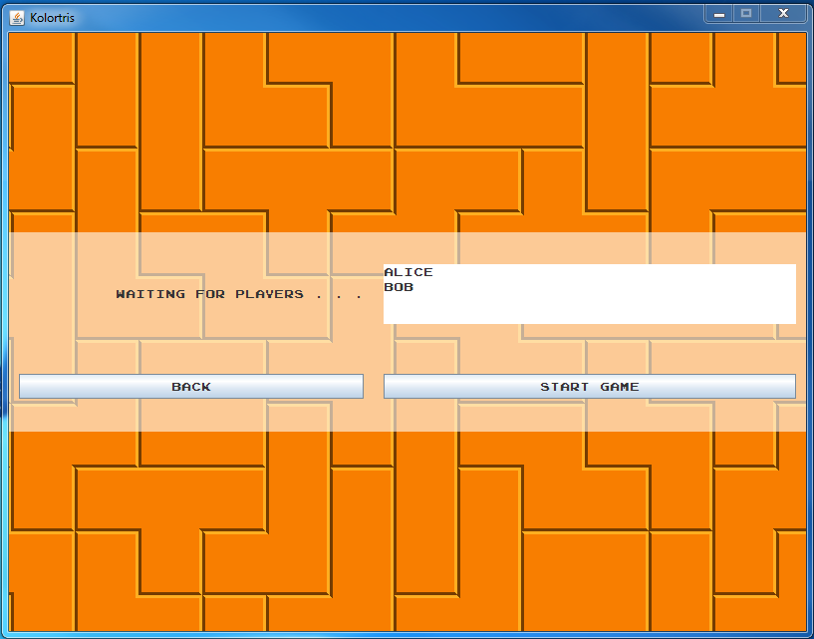

A list of all the players connected to this host.

Clicking the Start Game button will take you to the game screen (page 6) and start the game. A game can have anywhere from one to four players.

Clicking the Back button will take you back to the Multiplayer Setup screen (page 4)

# Join Game

The Join Game screen is used to connect to a game host. 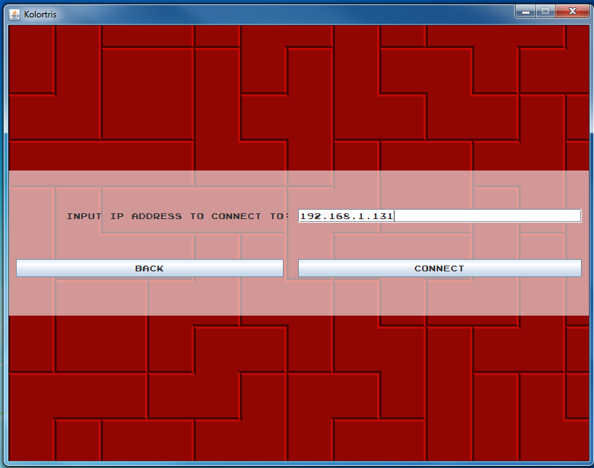

Input the IP address or host name of the host game here.

Clicking the Connect button will take you to the game screen (page 6) if connection is successful. The game will start when the host clicks the Start Game button on the Host Game screen (page 5)

Clicking the Back button will take you back to the Multiplayer Setup screen (page 4)

# Game Screen

## Rules

The Game Screen is where gameplay occurs. The objective of each game is to score the most points in 3 minutes. Points are scored by clearning blocks, and there are two ways to clear blocks.

* Form a solid horizontal line
* Connect 4 or more blocks of the same color.

Each block cleared is worth 10 points.

If your playfield overflows with blocks, your playfield resets.

## Default Controls

|  |  |
| --- | --- |
| Key | Function |
| Up | Rotates the current piece clockwise |
| Down | Moves the current piece downward |
| Left | Moves the current piece to the left |
| Right | Moves the current piece to the right |
| Shift | Holds the current piece |
| Space | Drops the current piece downward |

## Game Screen Layout

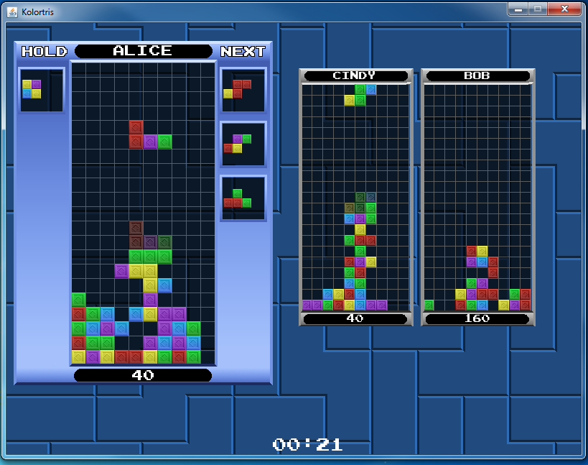

Your playfield.

The current piece you are controlling.

A ghost piece, which tells you where the piece will land if it moves downward.

The next queue: it shows you the pieces which you will get in the future.

The held piece is a piece you can save for later. Holding a piece keeps it in the Hold box. Holding a piece while there is a piece in the Hold box will swap the current piece and the held piece.

Your name.

Your current score.

The playfields of your opponents,

The time remaining in the game.

## Garbage Lines

Every time you get 150 points, a garbage line appears under the playfield of each of your opponents!

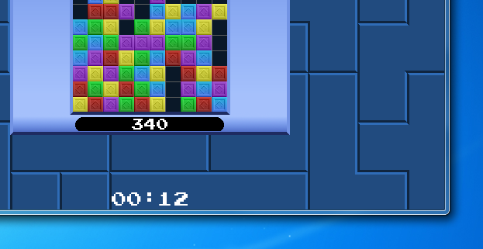

# Results Screen

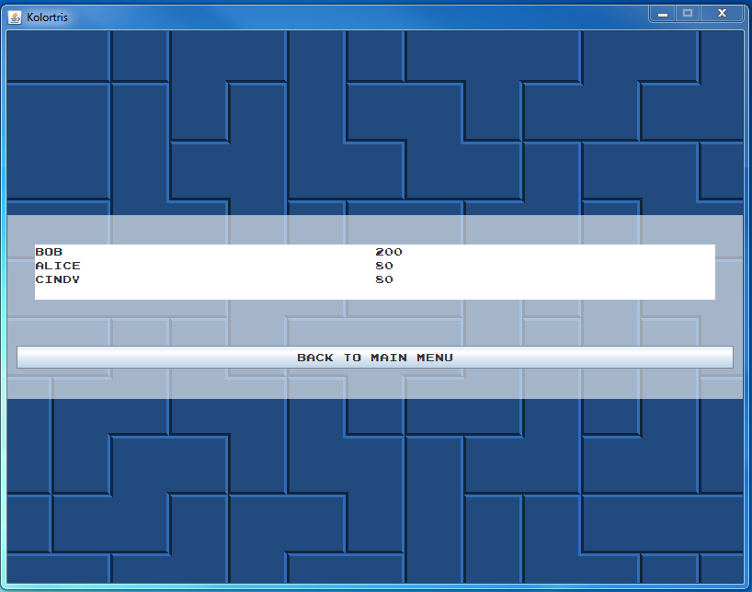

The results screen shows the scores of all the players.